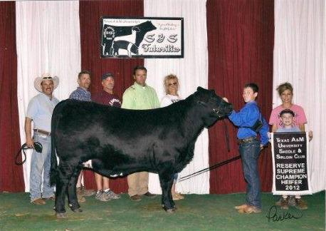

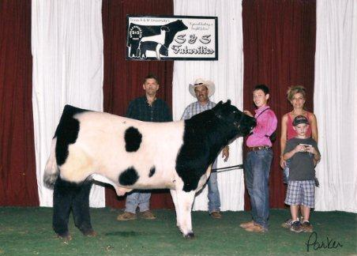
Braedan Raub, the 13 year old son of Darryl and Mary Raub and a Lampasas FFA
junior member won his breed division at the recent Texas A&M Saddle and
Sirloin Futurity Show held August 3-5, 2012 at the Brazos County Expo
Center. Braedan's Beefmaster breed heifer won her breed division and was
named overall Reserve Champion Beef heifer of the entire show.
Pictured at left his Darryle Raub,, Braedan Raub holding his heifer, Mary
Raub, and brother Cason Raub holding the Reserve Champion of Show banner

13 year old junior Lampasas FFA member Braedan Raub, son of Darryl and Mary
Raub exhibited the Champion Maine-Anjou steer at the recent Texas A&M Saddle
and Sirloin Club Futurity held August 3-5, 2012 at the Brazos County Expo
Center.
Pictured left to Right- Brian McCommas, Darryl Raub, Braedan Raub, Mary
Raub, and brother Cason Raub holding Braedan's Champion belt buckle.
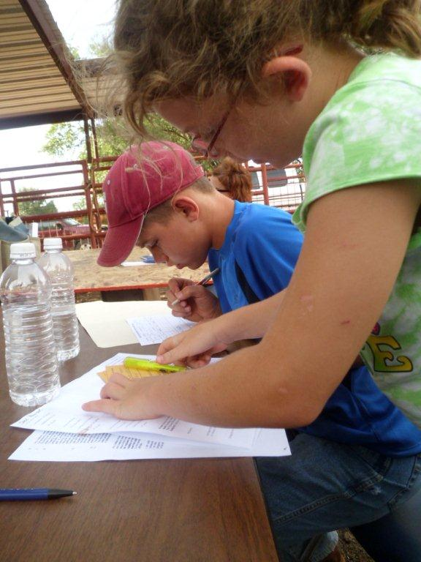

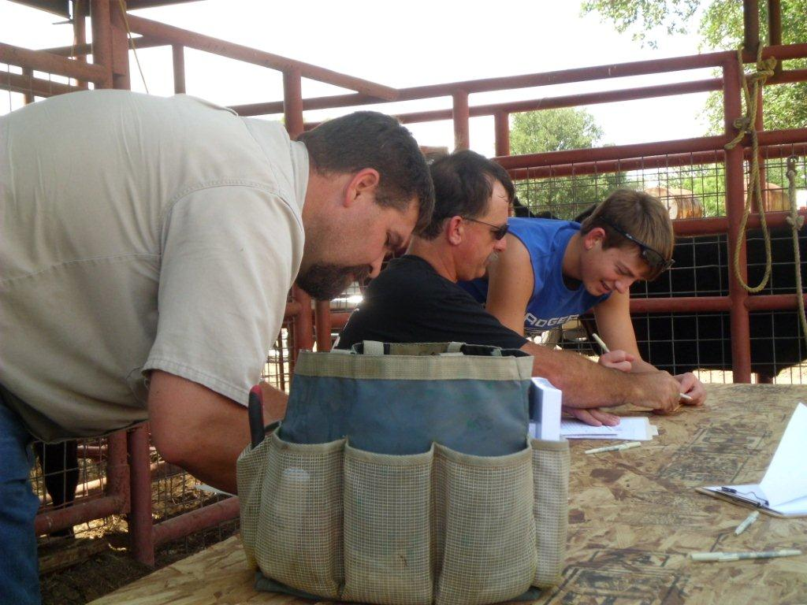
The Procter "clan" get signed up !

Dad Clay Greiner, Roy Cockrell, and son Kobie get paperwork done!

Landon Irvin and mom Tracy get "validated"!
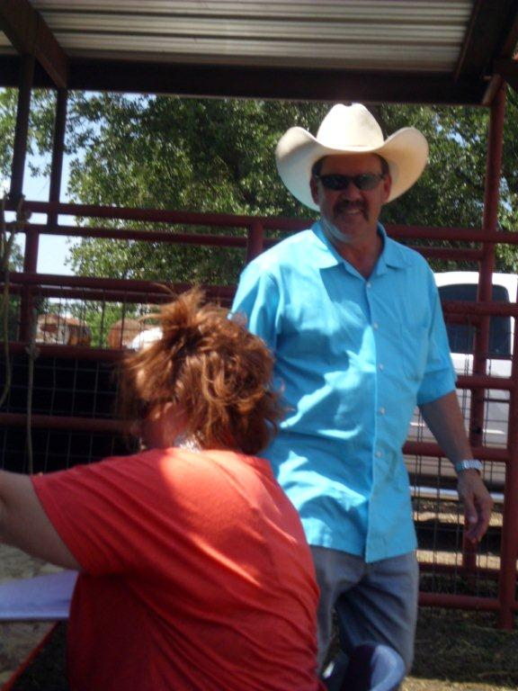

FFA - 4-H Steer validation- 55 steers!!!!
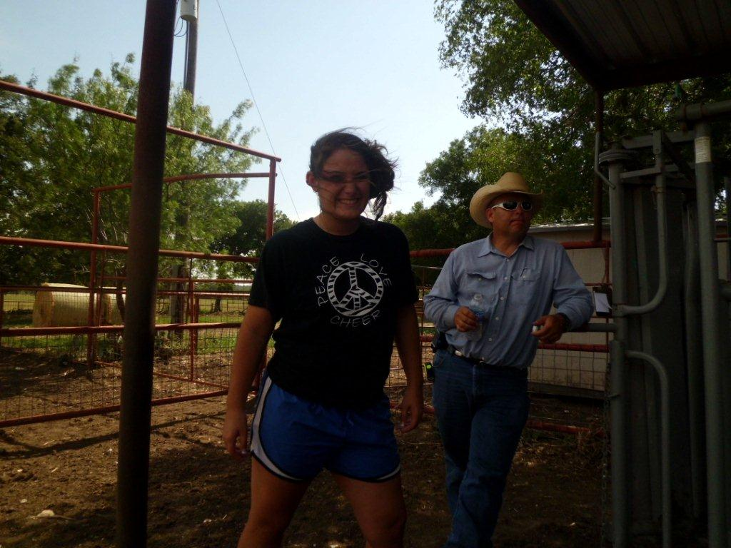

Crosby and Mr. P. “chillin”
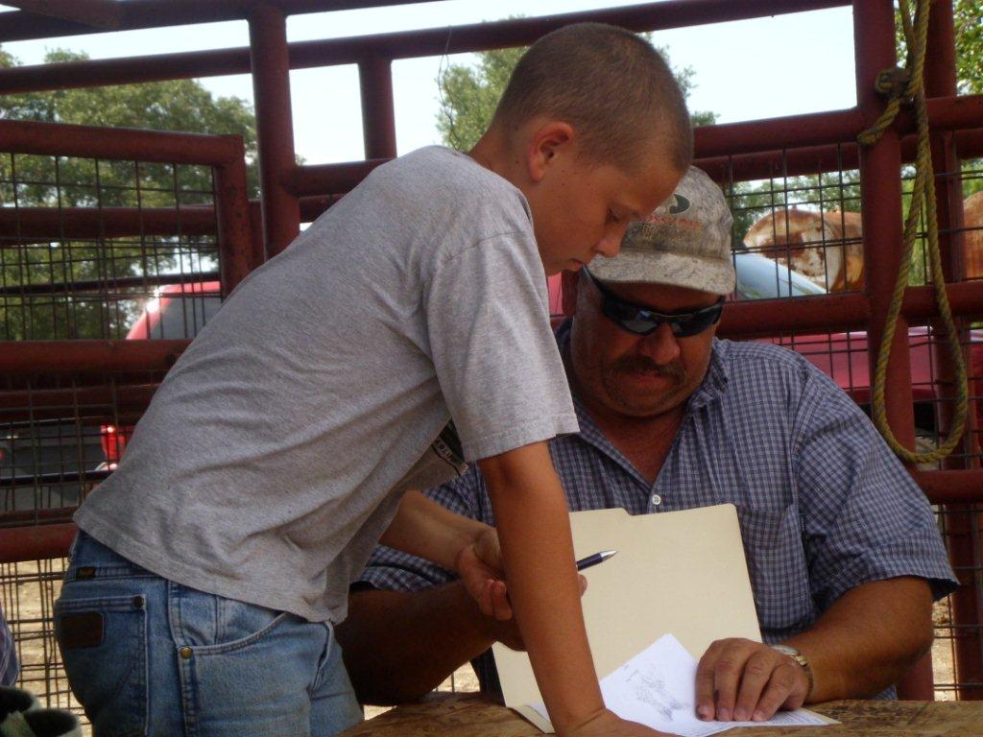

New FFA Jr. FFA steer exhibitor Levi Rainwater and dad Mark
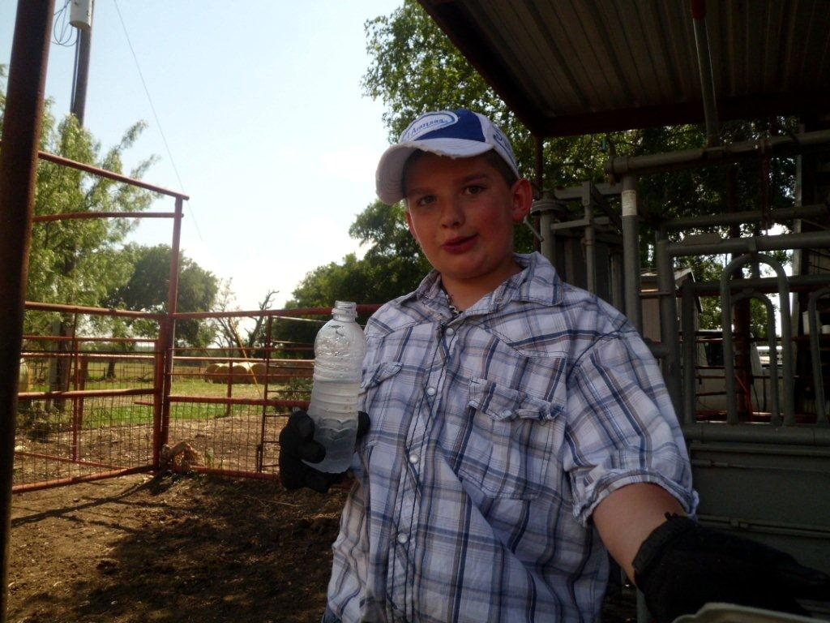
New FFA steer exhibitor Cooper Greiner
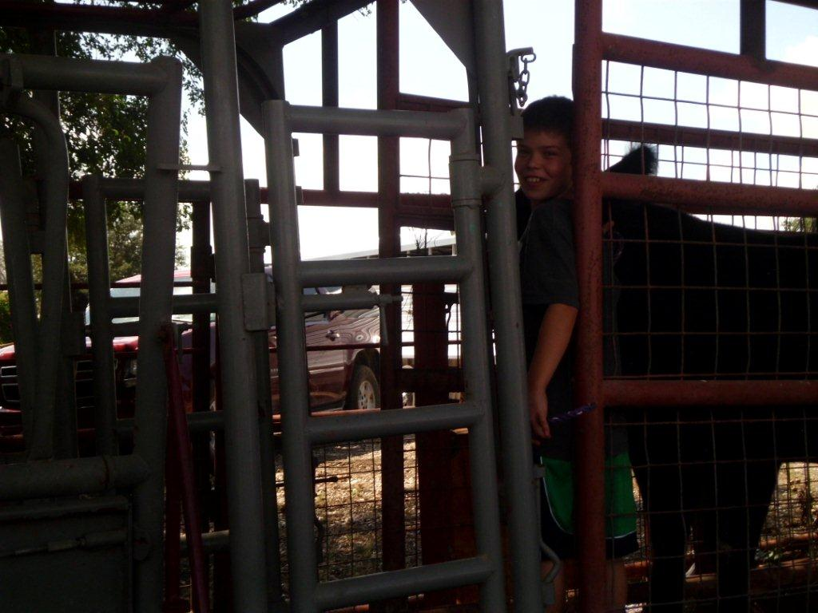

Junior FFA Member Dawson Raub
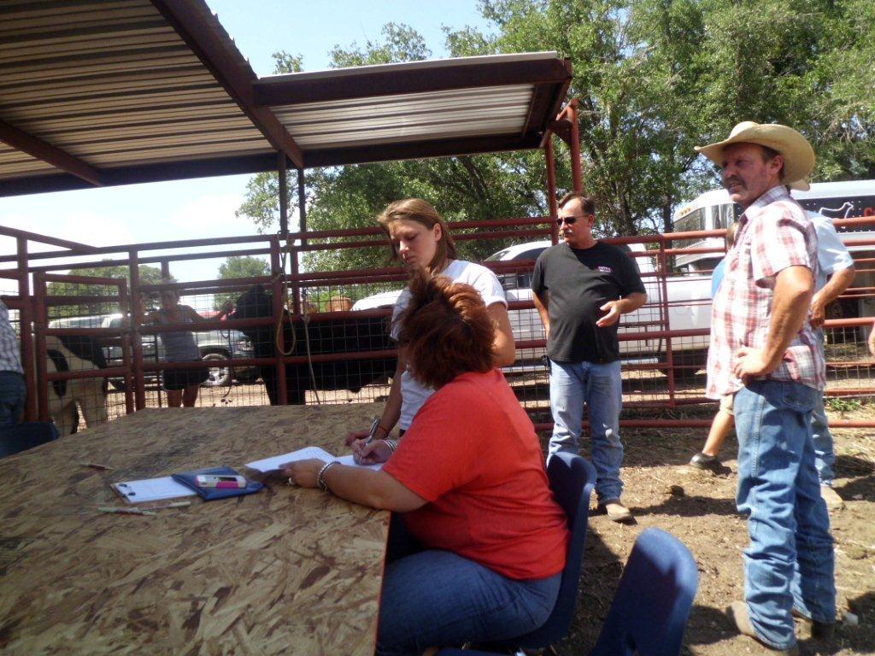
Steer validation- June 2012.
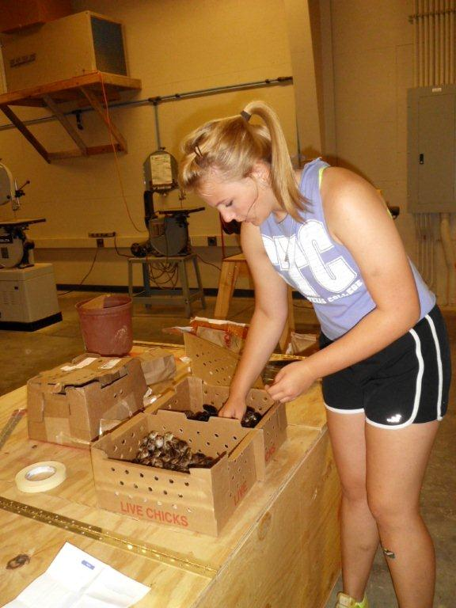
FFA Wildlife Science Quail project ongoing!!
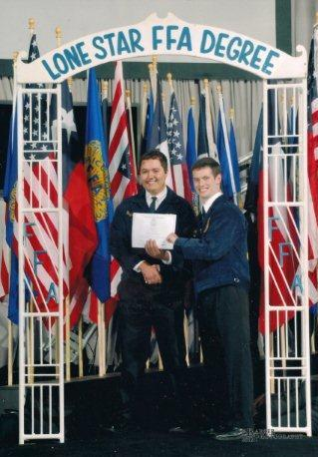
Blayze Bierschwale- LHS FFA Vice President and a senior at LHS recently
received his Lone Star FFA degree at the summer convention of the Texas FFA
Association. Blayze's program consists of market and beef heifers and market
broilers.
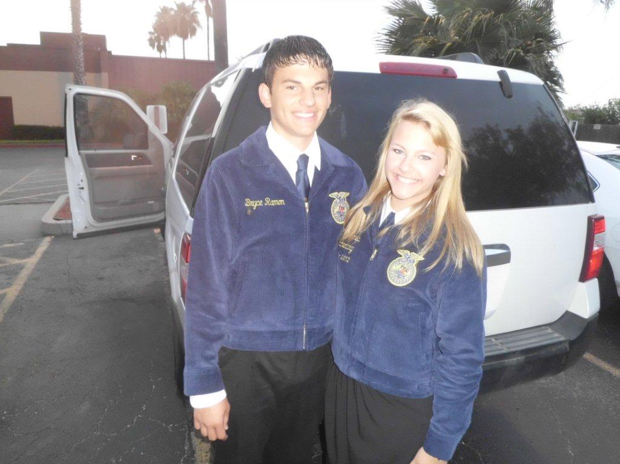
2012 Texas State FFA Convention
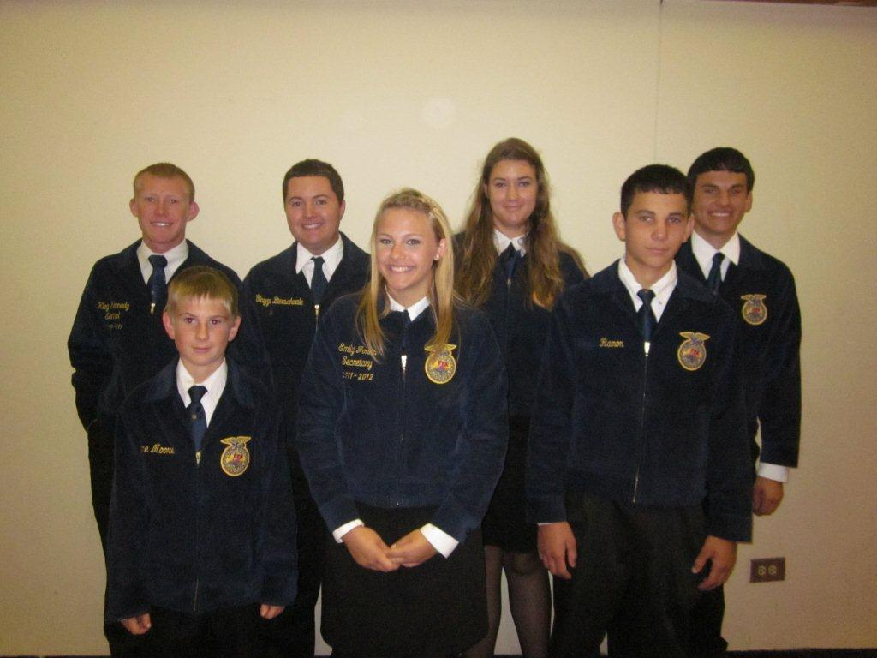
Lampasas Delegation Attends State FFA Convention- Garners State
Honors
The Lampasas FFA participated in the 2012 Texas FFA Convention held July
9-13, 2012 in Corpus Christi, Texas. Eight FFA Officers and members attended
along with adult advisors Ricky Prescott, Dr. Steve Forsythe, and Texas A&M
student teacher Caitlan Crane. Members Blayze Bierschwale, Dakota Dahlke,
Bryce Ramon, and Kleg Kennedy received their Lone Star FFA degree during
"Stars Night" ceremonies held July 11th, 2012. Kleg Kennedy was recognized
also as a State winner in Environmental Science Proficiency and received a
$1000 check. Mackenzie Martin received a $1000 Young Farmers of Texas
scholarship during awards ceremonies held July 12, 2012 and Hunter Webb
placed 4th in the junior division of the State FFA Agriscience Fair.
Front row - L to R- Shane Moore, Emily Jones, Nolan Ramon Back row- Kleg
kennedy, Blayze Bierschwale, Hunter Webb, Bryce Ramon Not pictured-
Mackenzie Martin
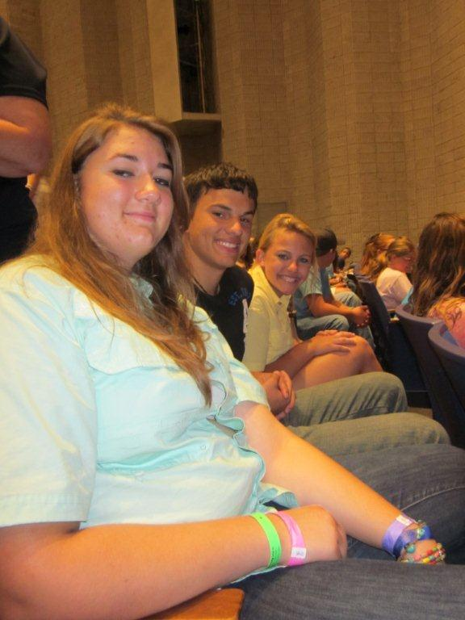
FFA members L to R- Hunter Webb, Emily Jones, and Bryce Ramon enjoy the
Hyptomist show as part of Thursday's "Fun Night" schedule held during the
Texas FFA State Convention conducted at Corpus Christi, Texas.
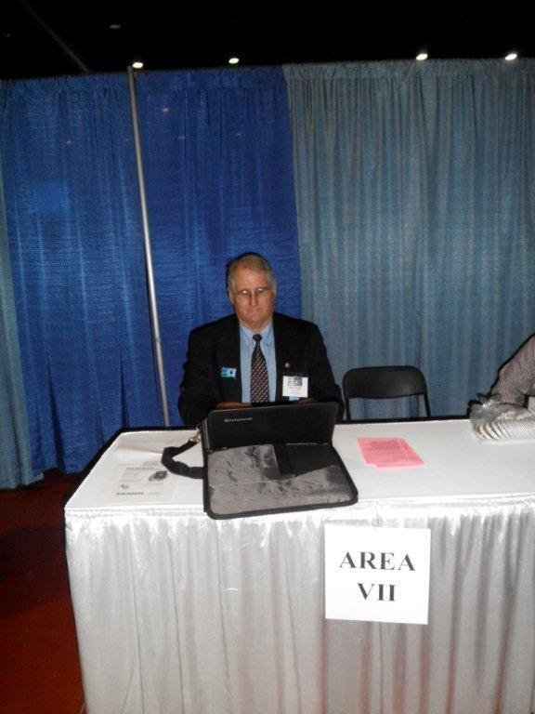
Dr. Steve Forsythe, Lampasas ISD Cate Coordinator and Agriscience/FFA
advisor worked the registration table for FFA members and guests during the
Texas FFA Convention . Over 10,000 FFA members and guests from across Texas
participated in the 2012 State FFA Convention
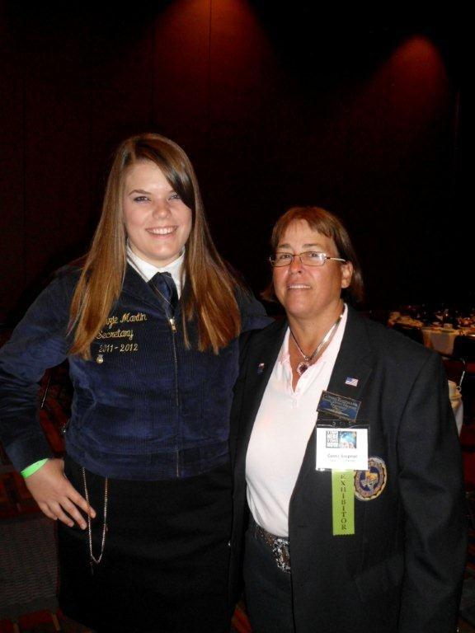
L to R- Lampasas FFA member and graduated senior Mackenzie Martin received
special recognition on stage and at the awards banquet hosted by the Texas
Young Farmers Association on Thursday, July 12th, 2012 in Corpus Christi,
Texas. She received a $1000 scholarship from 2012-2013 State Young Farmer
President Connie Koopman from Schulenburg, Texas.
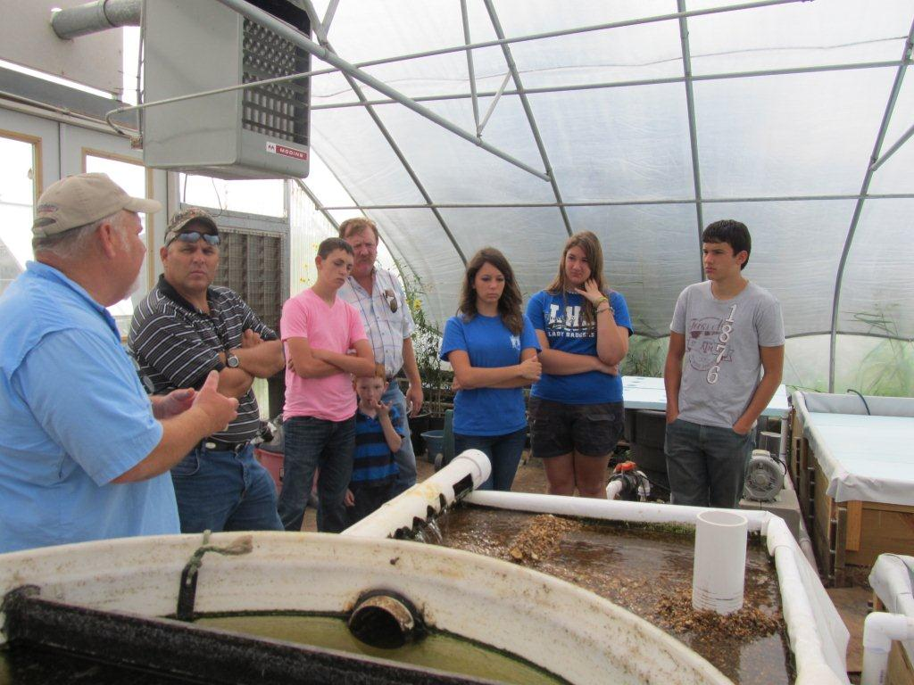
Perry Payne left- explains his Aquaponics sytem he has developed in
Fredericksburg, Texas to Lampasas and Lometa FFA/AgScienece students during
a recent tour to Fredericksburg, Texas. The Payne operation-called
Aquaponics uses the wastes/ammonia produced from the fish to grow plants and
the plants use and filter the nitrates produced by the fish,- in the water;
which allows species such as Koi, Talapia, and Gold fish to grow more
efficiently.
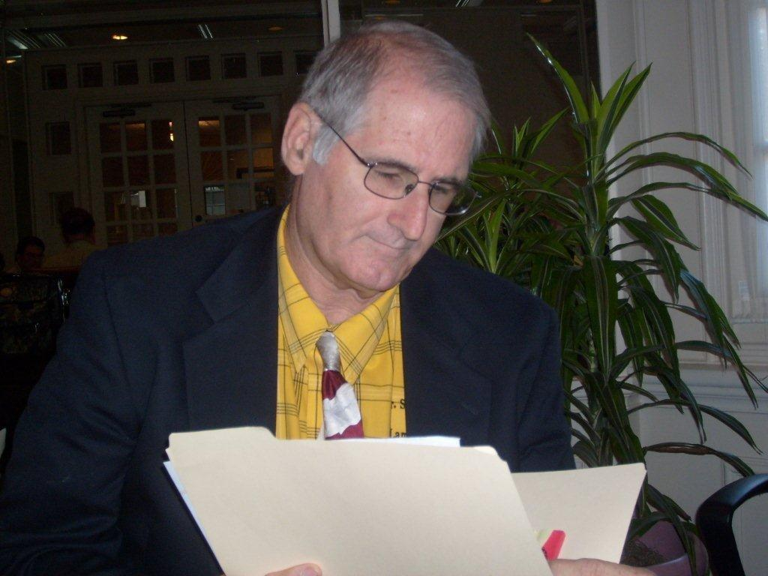
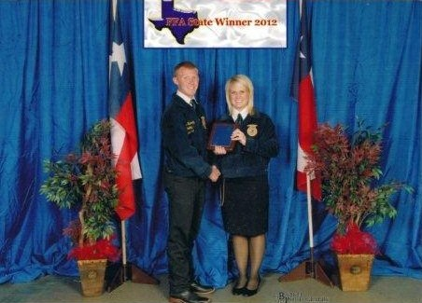

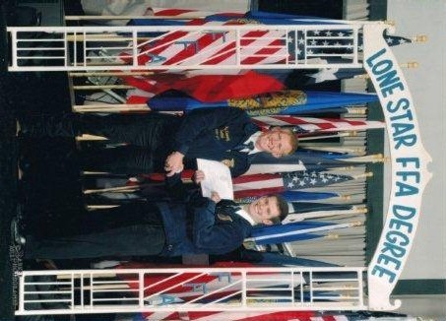

Lampasas FFA Chapter President Kleg Kennedy was recently named a National
FFA "Gold" rated winner in the National FFA Proficiency Awards Selection
meeting held August 10, 2012 in Indianapolis, Indiana. Kleg was named the
Texas FFA State Winner in the area of Environmental Science/ Placement and
represented the Texas FFA Association in the national rankings and selection
process completed this week. In addition to being the State FFA winner in
the area of Environmental Science, he was the state winner in Swine
Proficiency Placement. Because Texas can only send one winner per award
category, Kennedy competed in Environmental Science/Placement and will
compete again his senior year with additional focus in Swine Proficiency.
Kleg is the son of Terry Kennedy and Judy Kennedy Vann and Mike Hail.
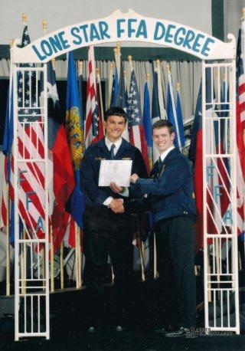
Bryce Ramon, a senior at LHS and the FFA Sentinel recently received his Lone
Star FFA degree at the summer Texas FFA Convention held in Corpus Christi,
Texas. Bryce's program was breeding and market swine and greenhouse
management enterprises
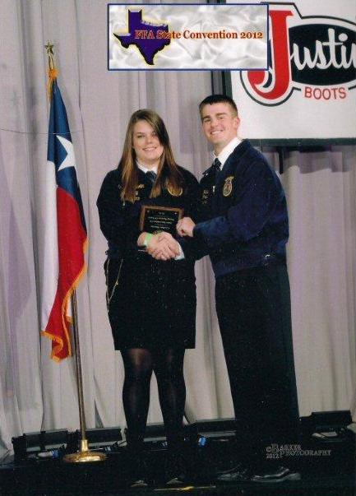
Mackenzie- Recent LHS graduate and past FFA President Mackenzie Martin
received a $1000 Texas Young Farmers State scholarship to assist her in her
University studies at Texas A&M University. Mackenzie was recognized at the
Texas FFA Convention held in Corpus Christi.

